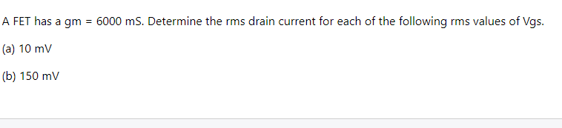

STEP1:

**FET:**

The field- effect transistor(FET) is a semiconductor device  that  controls the flow of current. FET is a three terminal device, Source, gate and Drain are the terminals of FET.

Types of FET:

* JFET (Junction Field Effect Transistors)
* MOSFET(Metal-Oxide-Semiconductor Field Effect Transistor)

STEP2:

